Steps to register for the   
2025 FBLA Middle Level Regional Conference

January 29, 2025

**Registration Opens: 11/15/2024**

**Registration Closes: Monday, 1/6/25 @ 5:00 pm**

**Steps for registering for Middle Level Regionals:**

1. Go to the Middle Level Regional Registration Link:
   * <https://www.registermychapter.com/fbla/az-ml>
2. Click on “Registration” Tab

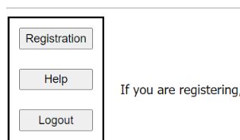

1. **If this is the first time registering for M/L Regionals, you must click “Add My Chapter”.** The red arrow denotes the link for registering your chapter for the first time. You will then enter a username and password. **PLEASE NOTE** this is a different login than the one you use for the national membership database system **UNLESS** you choose to make them the same.
2. I**f you have already started your registration for M/L Regionals**. You can simply type in your username and Password (yellow arrow) and then it will take you to your registration. **PLEASE NOTE** this is a different login than the one you use for the national membership database system **UNLESS** you choose to make them the same.

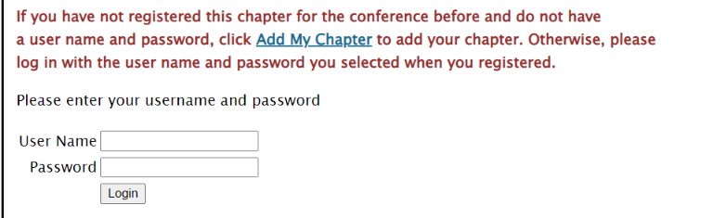

1. To add your chapter, put in all the required information (*); also circled in Red below.
   * This screen is where you will create your username and password. It can be anything you want that you will remember.
   * **Make sure you put your M/L chapter name in “School Name” area**, especially if there are more than two chapters at your school or if there is a high school with the same name.

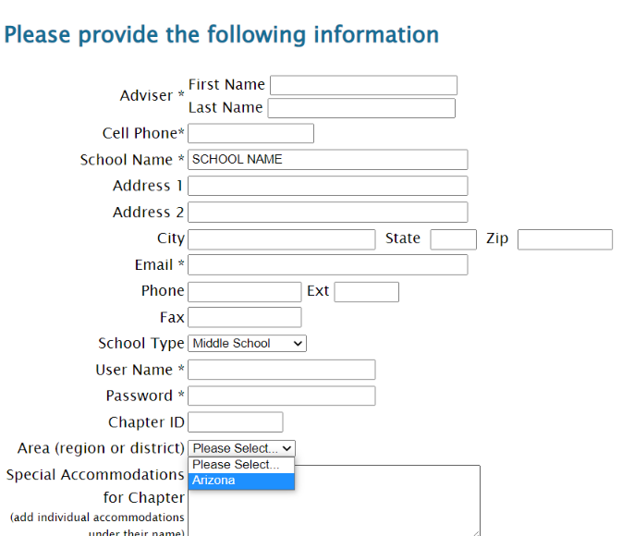

**School Name**, Not Adviser

Change to “Arizona”

1. Your registration will come up for the adviser. **Then click “Add New Name” to put in all your students.**

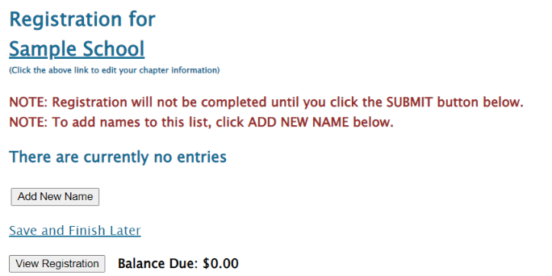

1. **Put in all the information for each student.** 
   * Spell names correctly (First and Last), as this is how we create name tags.
   * Choose what type of participant they are by using the down arrow- Middle School Member, or Adviser
     + How you register the participant will be directly related to the fee.
   * Make sure you put the correct grade for each competitor, but you don’t need their email (only adviser’s).
   * List any special needs per competitor in this section.
   * “Save” after each entry

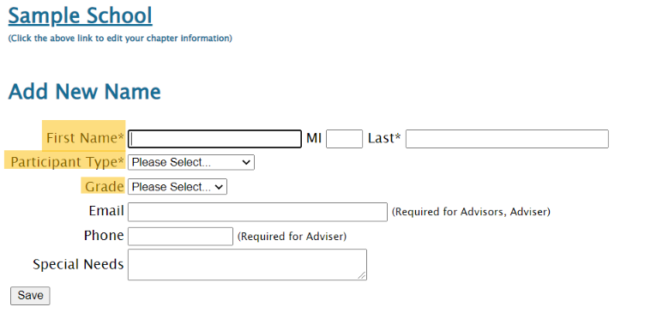

1. For each competitor, scroll down and **select (red box)** which events each student will compete in.
   * Please remember **each competitor can do up to 3 events for Regionals.**
     + **Each student can only compete in 2 performance events (either individual and/or team.**
       - Examples of registration:
         * *3 tests*
         * *1 test/1 individual performance/1 team*
         * *1 test/2 individual performances*
         * *1 test/2 teams*
   * See [Middle Level Competitive Event List-Regionals](https://www.azfbla.org/_files/ugd/71cc35_dd65508c89794dc19e3e930304e5cb85.pdf) to see the full list of all the M/L Events.
     + *Note, screen shot below does not show all the events offered.*
   * Team Performances can have 1-3 team members
     + You MUST select a Team Captain (1 student) per each team when registering.
   * Keep the “Team #” at “1” unless adding another team, then that team would be “2” and so on.
   * **You have NO event limits per chapter**
     + **You can enter as many students/teams per event, but you must follow the 3 events per student limit.**
   * Repeat the process until you have registered each person, saving each time.

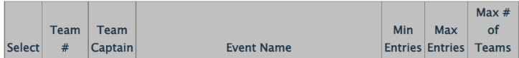

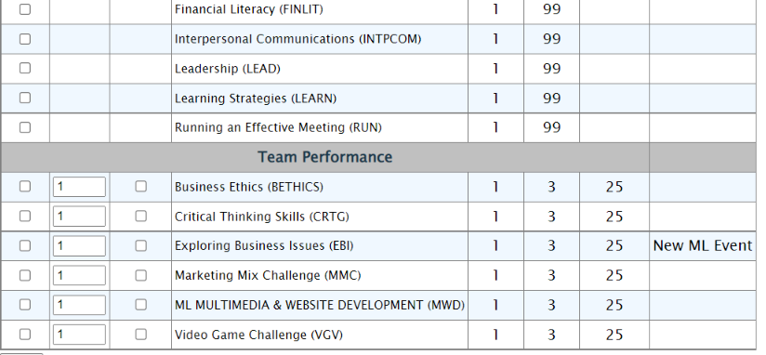

1. After you check the accuracy of all your students, then you can submit your registration.

* Click “Save & Finish Later” while you are working on your registration; however, once you are done you can hit “Submit”.
  + You can “Submit” Multiple times.
    - **RECOMMENDATION: Hit “Submit” every time you make changes to make sure your Registration is the most accurate.**
  + A Quote will be generated for you as you hit “Submit”, but you will not receive an invoice until after Registration has closed.
* You can make changes any time during registration opening, but a “Final” submit should be made by the 1/05/24 deadline.

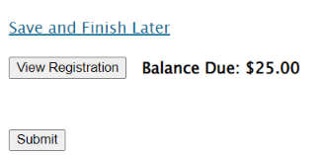

**Use as working on Registration**

**Use when done with Registration**

**FINAL REGISTRATION MUST BE SUBMITTED BY MONDAY, JAN. 6, 2025, BY 5:00 PM.**

**Note, you can make changes to registration even after you have submitted up until the Registration closes @ 5:00 pm on 1/06/25.**

* If you have students who you know did not submit their pre-submission item(s), please go in and edit their registration to reflect what they are competing in at Regionals.
  + By each adviser cleaning up their registration, it helps with getting the results done faster in headquarters because then we know we are not missing a student’s event.
  + It also helps get the schedules out faster before Regionals.
  + The adviser’s help with making sure students are registered correctly, is appreciated. 😊

**If you have any questions regarding registration, contact Competitive Event Coordinator, Seth Filo @****seth.filo@azfbla.org** **or 480-685-0798 or FBLA State Adviser, Missey Goodman @missey.boucher-goodman@azed.gov or 602-364-2339.**