Steps to register for the   
2025 FBLA REGIONAL CONFERENCE (High School)

**REGISTRATION OPENS: November 15, 2024**

**REGISTRATION CLOSES: January 6, 2025@ 5 p.m.**

**STEPS FOR REGISTERING FOR Regionals:**

1. Figure out what Region your school is. You MUST attend your correct Region and Regional date.
2. Not sure of your school’s Region? Click the link to find out. [Arizona FBLA Chapters by Region](https://www.azfbla.org/_files/ugd/fff265_d70d0034166647c5ab3e2517374a2691.pdf)
3. Go to your Specific Regional Registration Link:

|  |  |  |
| --- | --- | --- |
| **Region 1 Conference** | 01/23/2025 | [**https://www.registermychapter.com/fbla/az-r1**](https://www.registermychapter.com/fbla/az-r1) |
| **Region 2 Conference** | 01/22/2025 | [**https://www.registermychapter.com/fbla/az-r2**](https://www.registermychapter.com/fbla/az-r2) |
| **Region 3 Conference** | 01/25/2025 | [**https://www.registermychapter.com/fbla/az-r3**](https://www.registermychapter.com/fbla/az-r3) |
| **Region 4 Conference** | 01/15/2025 | [**https://www.registermychapter.com/fbla/az-r4**](https://www.registermychapter.com/fbla/az-r4) |
| **Region 5 Conference** | 01/18/2025 | [**https://www.registermychapter.com/fbla/az-r5**](https://www.registermychapter.com/fbla/az-r5) |

1. Click on “Registration” Tab

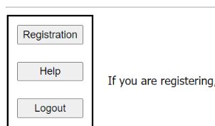

1. **If this is the first time registering for Regionals, you must click “Add My Chapter”.** The red arrow denotes the link for registering your chapter for the first time. You will then enter a username and password. **PLEASE NOTE** this is a different login than the one you use for the national membership database system **UNLESS** you choose to make them the same.
2. I**f you have already started your registration for Regionals**. You can simply type in your username and Password (yellow arrow) and then it will take you to your registration. **PLEASE NOTE** this is a different login than the one you use for the national membership database system **UNLESS** you choose to make them the same.

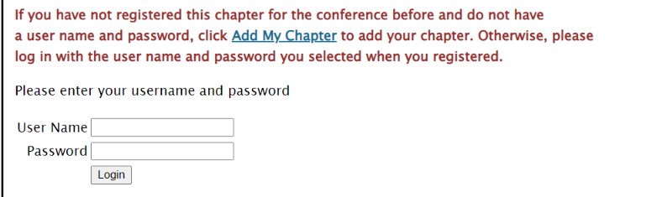

1. To add your chapter, put in all the required information (*); also circled in Red below.
   * This screen is where you will create your username and password. It can be anything you want that you will remember.
   * DON’T USE AUTOFILL!!!!!
   * **Make sure you put your chapter name exactly how it appears in the national database system in “School Name” plus the CTE Program,** especially if there are more than two chapters at your school.
     + For example: “XYZ High School-Business” & “XYZ High School-Media” denotes 2 different chapters.
   * REQUIRED: Add One of The CTE Programs: “Media”, “Business” or “IT” to the end of your Chapter Name so we know what CTE Program you so we know for extra events.
     + - *Example: “Sample High School-Business”*

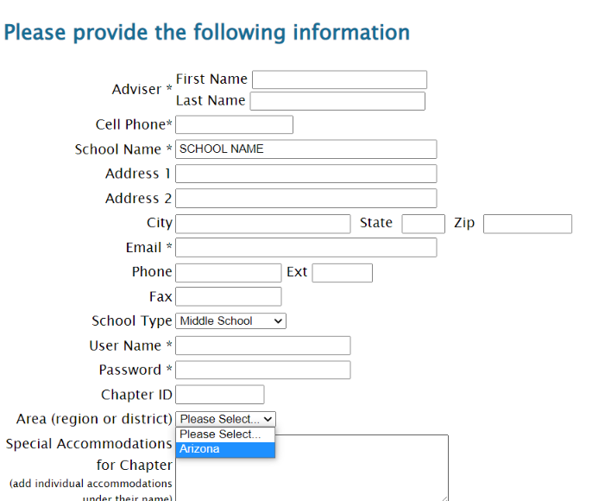

**Change to “High School”**

**Change to “Arizona”**

**Chapter Name, Not Adviser-Add CTE Program to End**

**Chapter Name, Not Adviser-Add CTE Program to End**

1. Your registration will come up for the adviser. **Then click “Add New Name” to put in all your students.**

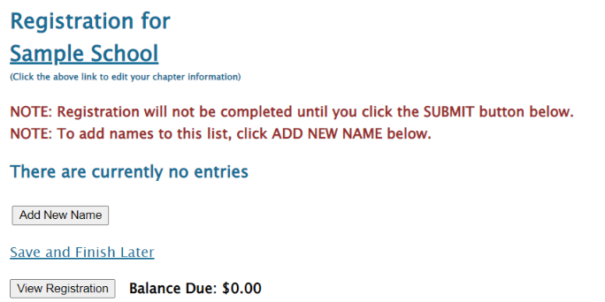

1. **Put in all the information for each student.** 
   * **Spell names correctly** (First and Last), as this is how we create name tags.
   * Choose what type of participant they are by using the down arrow- High School Member, Current State Officer, or Chaperone.
     + How you register the participant will be directly related to the fee.
   * Make sure you put the correct grade for each competitor, but you don’t need their email (only adviser’s).
   * List any special needs per competitor in this section.
   * “Save” after each entry



1. For each competitor, scroll down and **select** which events each student will compete in.
   * Please remember each competitor can do up to 3 events for Regionals.
   * Two of the events can either be Team and/or Individual events.
     + See [FBLA Regional Competitive Event List](https://www.azfbla.org/_files/ugd/71cc35_119c0646143e4235b971f71488566d61.pdf) to help you determine which events you receive more entries in **Remember you get more entries per event specific to your CTE Program, but ALL Events are open to EVERYONE.**
     + For Teams, **you MUST select a Team Captain for team events**-*1 team captain per team, can be anyone on the team.*
     + Teams consist of 1-3 students.
     + Keep the Team # “1” unless you want to add another team to that event. Then you would put “2” and so on.
       - **Remember to keep Event Limits in mind when creating more than 1 team per event, even though it says “8” as a MAX (red arrow), your number is based on your student conference registration, not membership (*see next page*).**
   * Repeat the process until you have registered each person, saving each time.



**One student designated “Captain”-Required for teams in C & D**

**MAX is Based on your Registration # and/or CTE Program**

1. MOST IMPORTANT POINT WITH REGISTRATION- As you put in the registration, **you must follow the guidelines for how many students and teams you can put in individual and team events.** 
   * This number is based on how many students you register for the conference **NOT** your membership number.
   * NEW-Now based on CTE Program, you can enter more per teams/individuals per event in certain CTE Program Groups. See the Competitive Event List for CTE Program Event Categories.
   * Basically, the more students you register, the more you can put in each event. Students can do any combination of individual and team events, including two individual events, two team events, or one of each.
   * **Event limits are PER EVENT.**

**Please see the limits below:**

**1 2. After you check the accuracy of all your students and make sure you follow the Chapter Limits per event, then you can submit your registration.**

* Click “Save & Finish Later” while you are working on your registration; however, once you are done you can hit “Submit”.
  + You can “Submit” Multiple times.
    - **RECOMMENDATION: Hit “Submit” every time you make changes to make sure your Registration is the most accurate.**
  + A Quote will be generated for you as you hit “Submit”, but you will not receive an invoice until after Registration has closed.
* You can make changes any time during registration opening, but a “Final” submit should be made by the 1/05/24 deadline.

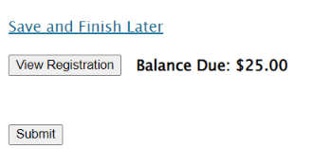  


FINAL REGISTRATION MUST BE SUBMITTED on or before 1/6/25 by 5:00 pm!

13. **Note, you can make changes to registration even after you have submitted up until the Registration closes @ 5:00 pm on January 6, 2025**

* If you have students who you know did not submit their pre-submission item(s), please go in and edit their registration to reflect what they are competing in at Regionals.
  + By each adviser cleaning up their registration, it helps with getting the results done faster in headquarters because then we know we are not missing a student’s event.
  + It also helps get the schedules out faster before Regionals.
  + The adviser’s help with making sure students are registered correctly, is appreciated. 😊

**If you have any questions regarding registration, contact Competitive Event Coordinator, Seth Filo @****seth.filo@azfbla.org** **or 480-685-0798 or FBLA State Adviser, Missey Goodman @missey.boucher-goodman@azed.gov or 602-364-2339.**